ASSIGNMENT- 1

Computer Languages

The computer languages are those languages by which the user can communicate with the machine.

There are various types of programming languages via we can write the programs.

The program is the set of instructions which has to be executed by the computer.

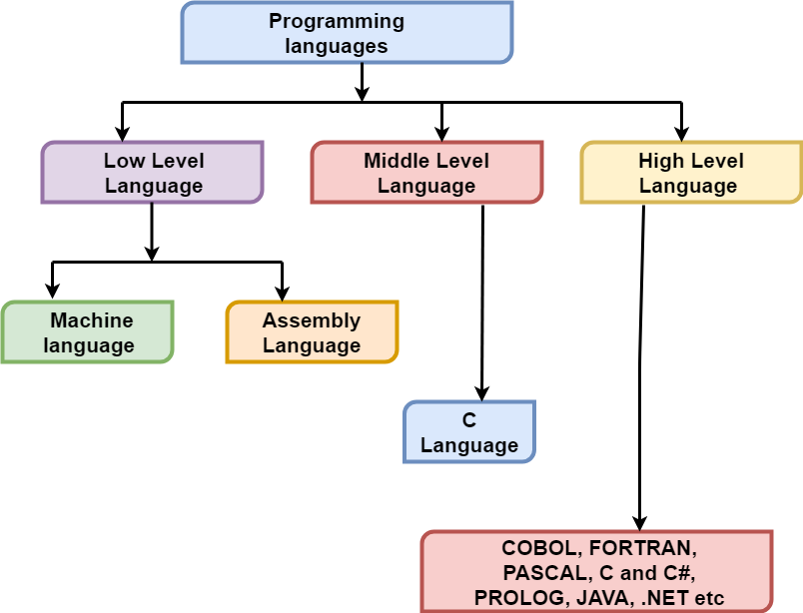

Low level programming language

A low-level programming language is a programming languagethat provides little or no abstraction from a computer's instruction set architecture—commands or functions in the language map closely to processor instructions.

Generally, this refers to either machine code or assembly language

The low abstraction between the language and machine language, low-level languages are sometimes described as being "close to the hardware".

. A program written in a low-level language can be made to run very quickly, with a small memory

An equivalent program in a high-level language can be less efficient and use more memory.

Low-level languages are simple, but considered difficult to use, due to numerous technical details that the programmer must remembe

Middle-level language

The middle-level language lies in between the low level and high-level language. C language is the middle-level language.

By using the C language, the user is capable of doing the system programming for writing operating system as well as application programming.

The C++ are also middle-level languages.
The middle-level programming language interacts with the abstraction layer of a computer system. It serves as the bridge between the raw hardware and programming layer of the computer system.

The middle-level language is also known as the intermediate programming language

High-Level Language

The high-level language is the programming language such as BASIC, C, C++, COBOL, FORTRAN, Java, Perl, PHP, Python, Ruby, Visual Basic, and Pascal, etc.

These languages have strong abstraction, the style and the context which are more comfortable to learn.

The high-level languages are closer to human languages and far from machine languages. It is similar to human language, and the machine is not able to understand this language.

High-level languages are coders friendly, easy to code, debug, and maintain. These languages do not interact directly with the hardware.

These languages are easy to implement. The software of translation plays an important role in the conversion of a high-level language to machine level language

ASSIGNMENT- 2

Cloud Network

Cloud network is referred to a computer network that exists within or is part of a cloud computing infrastructure
.
It is a computer network that provides network interconnectivity between cloud based or cloud enabled application, services and solutions.

Cloud network can be cloud based network or cloud enabled network.

For example, a cloud network will enable connecting a remote user with a cloud application (SaaS) softwar as a service or cloud infrastructure (IaaS).

. Similarly, cloud network also enables the network communication between virtual machines.

Types of Cloud Services
Regardless of the kind of service, cloud computing services provide users with a series of functions including:

- Email
- Storage, backup, and data retrieval
- Creating and testing apps
- Analyzing data
- Audio and video streaming
- Delivering software on demand

